Name: Quang Huynh

Epithelial Tissues Practice and Review

Directions: Answer the questions in each section below to review the basic principles of the structure and function of epithelial tissues.

Short answer:

1. Define tissue: Tissues are groups of cells that have specific functions.
2. List the 4 major types of tissues:

*

*

*

*

1. What are the general characteristics of epithelial tissue?

o

o

o

o

o

1. What two criteria are used to classify and name epithelial tissue?

_______________________________ _______________________________

Identify: Label the diagrams with the following choices: **simple columnar**, **transitional**, **stratified squamous**, **simple cuboidal**, **simple squamous**, **pseudostratified columnar**

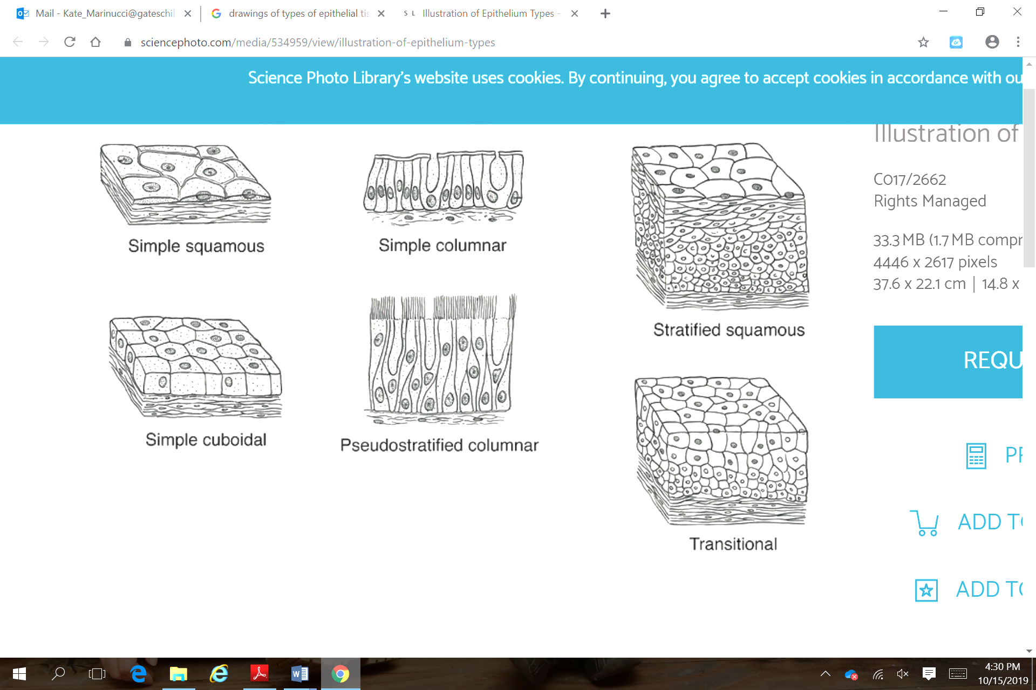

5. 6. 7.

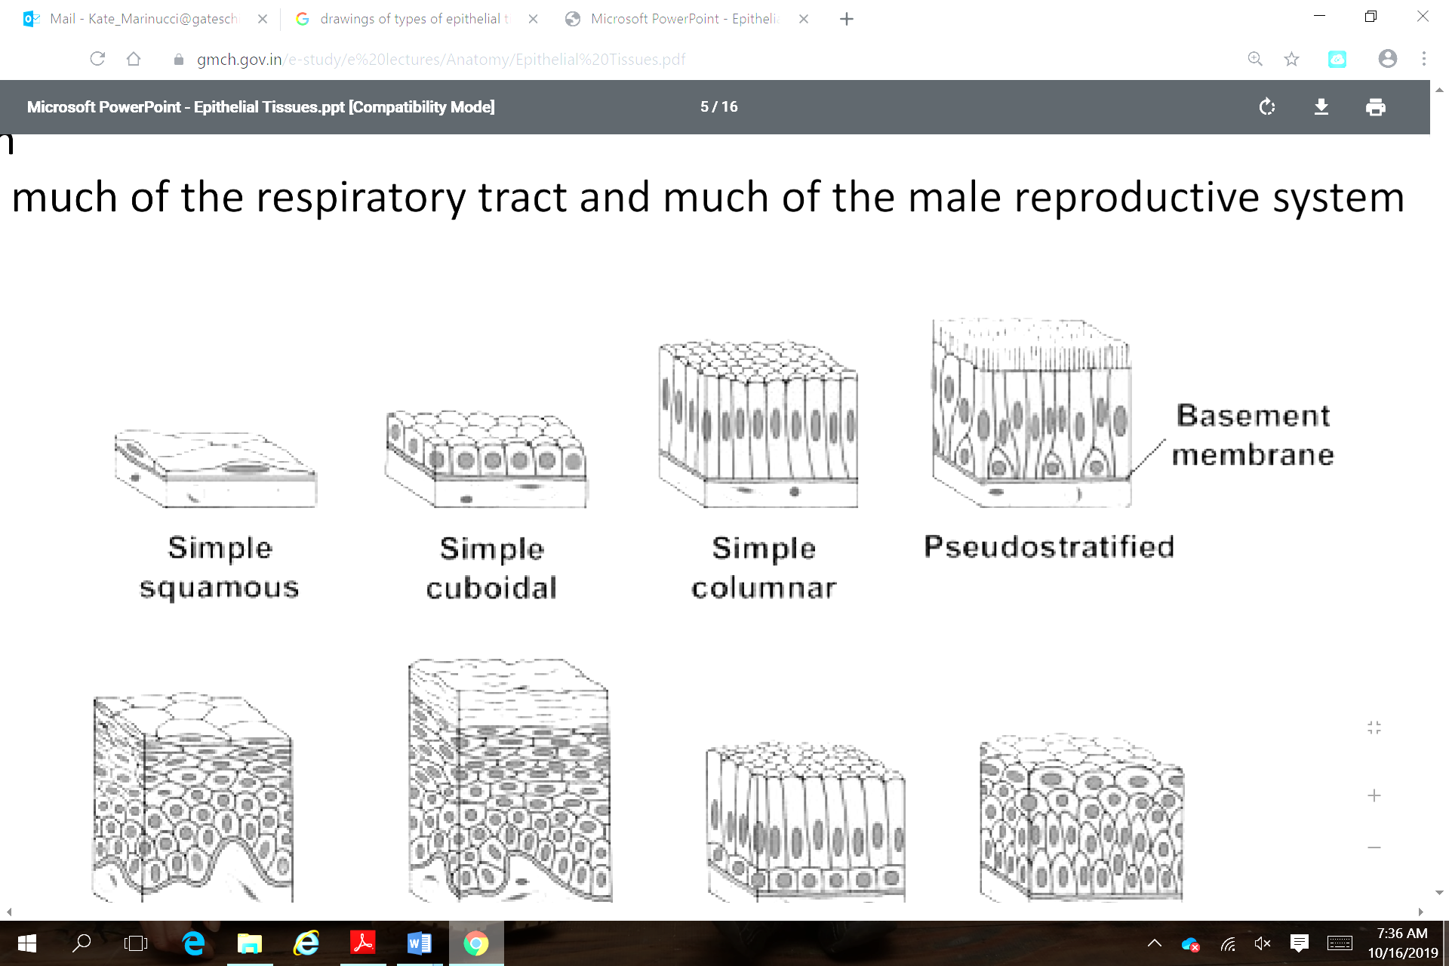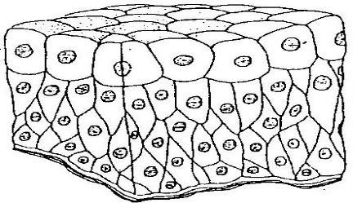

8. 9. 10.

Fill in: Fill in the blanks below using the word choices provided.

**Tissue Squamous Simple**

**Stratified Cuboidal Glandular**

**Transitional Pseudostratified**

11. One single layer of cells _________________________________________________

12. Tissue that specializes in secretion ________________________________________

13. Cube shaped cells ______________________________________________________

14. Many layers of cells______________________________________________________

15. A group of cells with the same specialized purpose________________________

16. A group of cells that *appear* to be in layers _______________________________

17. Flat cells that cover many body parts and glands _________________________

18. Tissues whose cells change size and shape _______________________________

**Simple Squamous Simple Cuboidal Simple Columnar**

**Pseudostratified Columnar Stratified Squamous**

**Stratified Cuboidal Stratified Columnar Transitional**

**Basement Membrane**

19. Long cells with nuclei near basement membrane __________________________

20. Specialized cells to react to tension/stress _________________________________

21. Single flat layer of cells ___________________________________________________

22. Tissues that make up skin _________________________________________________

23. Tissues that line the respiratory system and trap dust and microorganisms _________________________________________________________________________

24. Layers of cube shaped cells ______________________________________________

25. Tissues with centrally located, spherical nuclei _____________________________

26. The underside of epithelial tissue is always anchored to connective tissue by the _________________________________________________________________________

27. Tissues that line the male urethra, vas deferens, and the pharynx

________________________________________________________________________

28. Label the diagram below with the following terms:

* Basement Membrane
* Apical Surface
* Connective tissue
* Blood vessel
* Nucleus
* 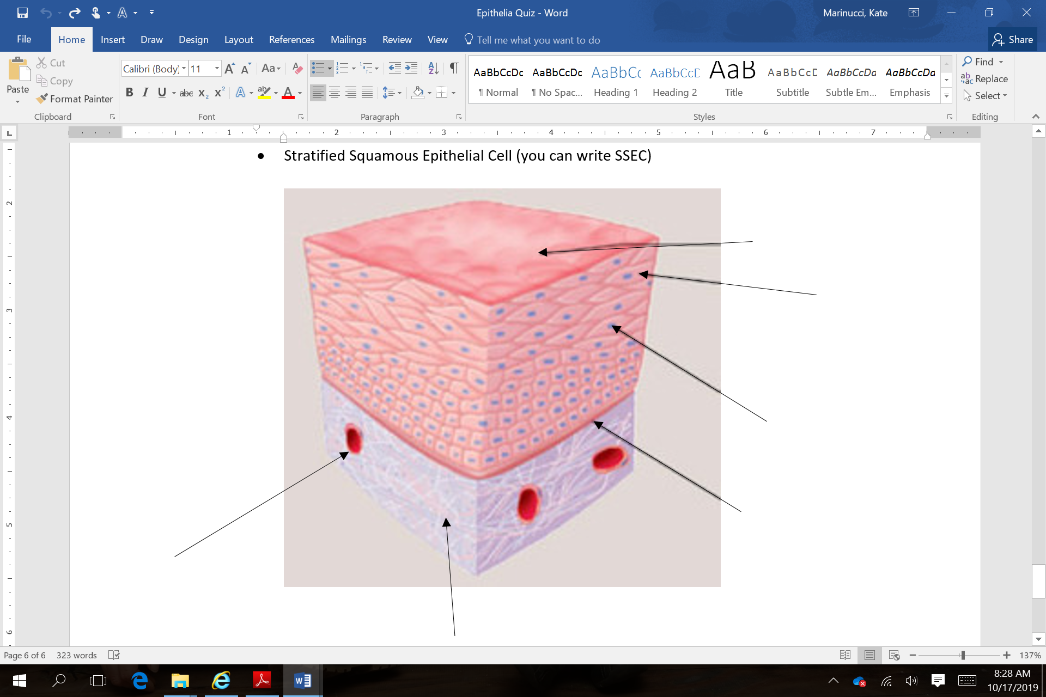Stratified Squamous Epithelial Cell (you can write SSEC)

29. Match the epithelial tissue to an organ in which the tissue is

_____ (1) simple squamous epithelium A. lining of intestines

_____ (2) simple cuboidal epithelium B. lining of ducts of mammary glands

_____ (3) simple columnar epithelium C. lining of urinary bladder

_____ (4) pseudostratified columnar epithelium D. salivary glands

_____ (5) stratified squamous epithelium E. air sacs of lungs

_____ (6) stratified cuboidal epithelium F. respiratory passages

_____ (7) stratified columnar epithelium G. parts of male urethra

_____ (8) transitional epithelium H. lining of kidney tubules

_____ (9) glandular epithelium I. outer layer of skin

30. What is a goblet cell and what does it do?